High Level Design

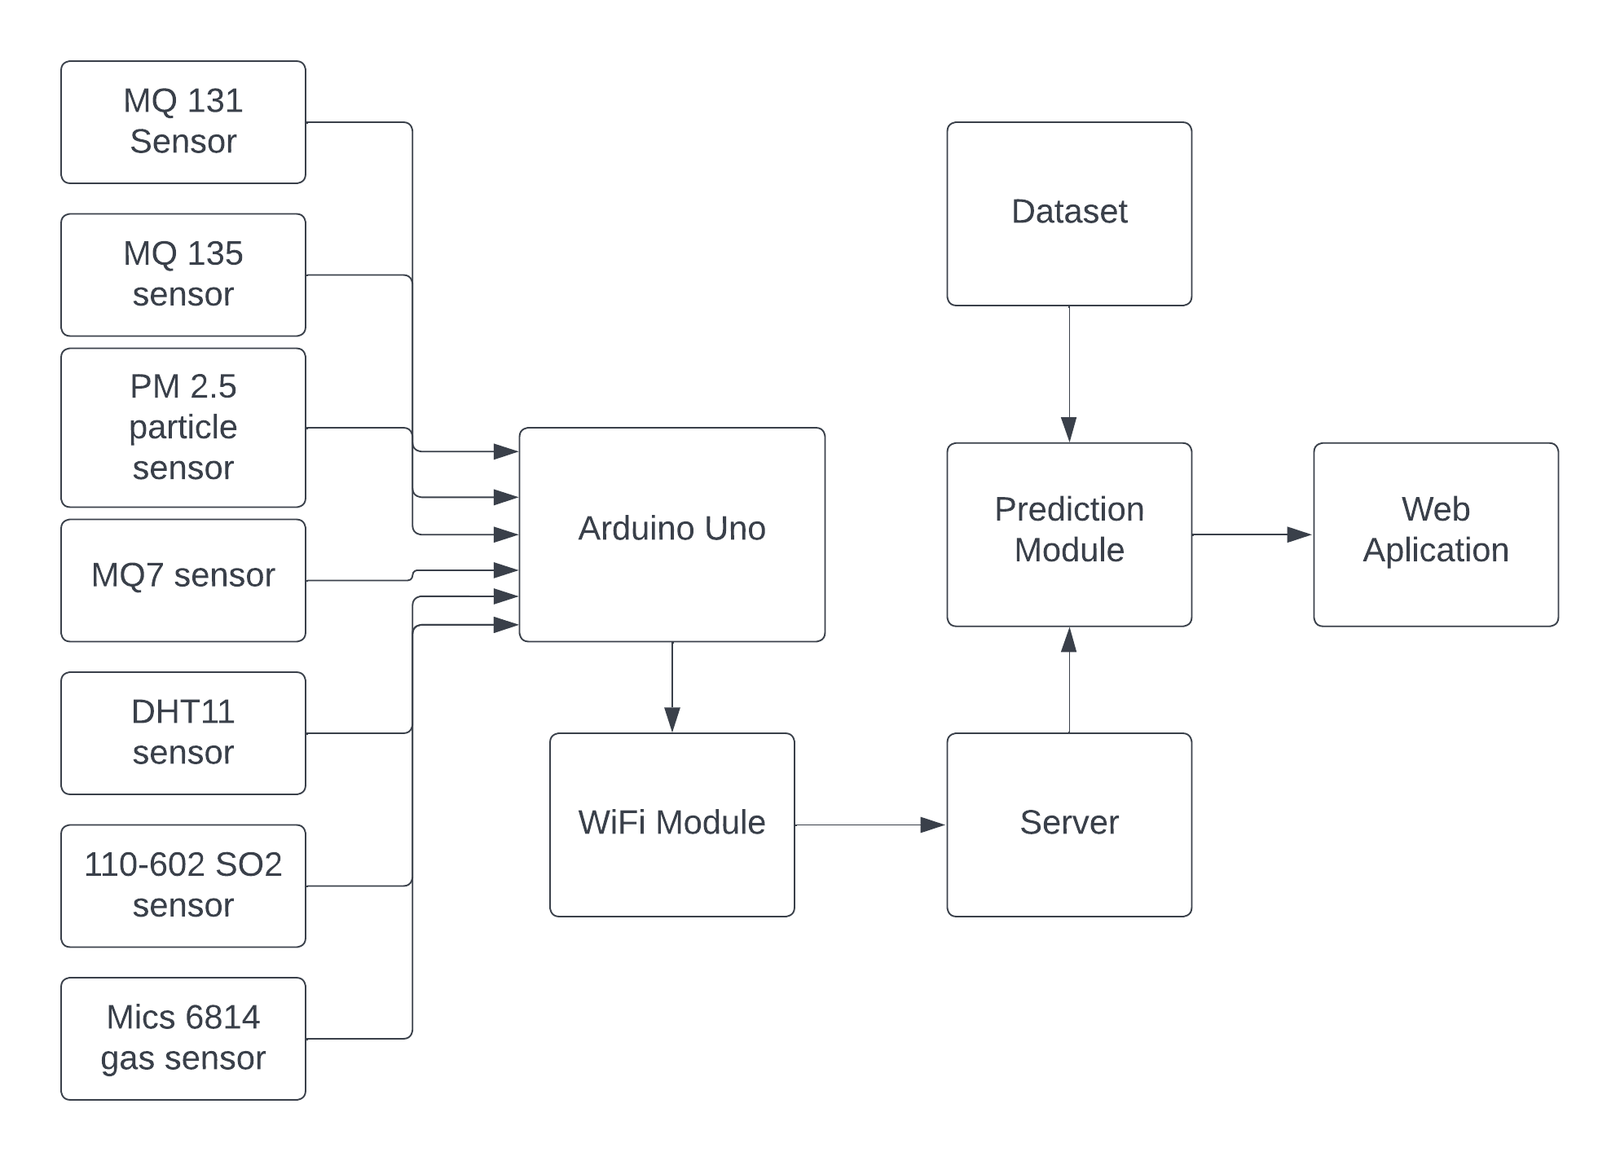

System Architecture

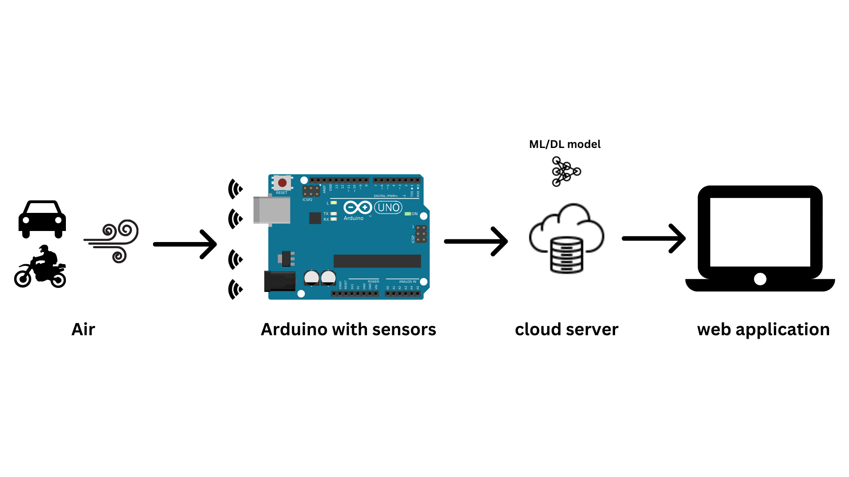

Sensors: Collect data from the physical environment (e.g. temperature, humidity, etc.).

Gateway: Acts as a bridge between the devices and the cloud. It filters and processes the data before sending it to the cloud.

Cloud Platform: Stores and manages the data, provides APIs for data access, and runs analytics and machine learning algorithms.

Mobile/Web App: Provides a user-friendly interface to interact with the system and view data insights.

Network: The devices communicate with the gateway and the cloud through a secure and reliable network (e.g. Wi-Fi, cellular, etc.).

Activity flow diagram
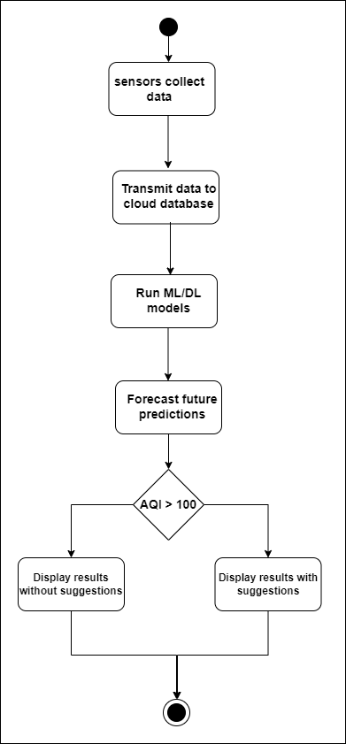
All modules
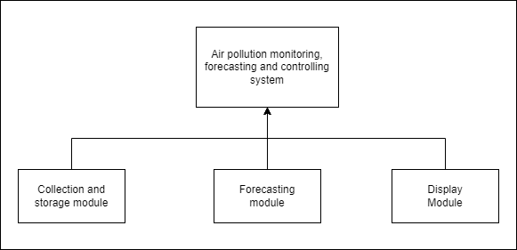
Module 1
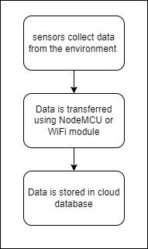

Module 2 design
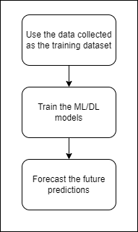

Module 3 design
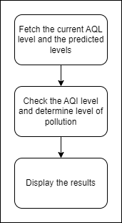

Class Diagram
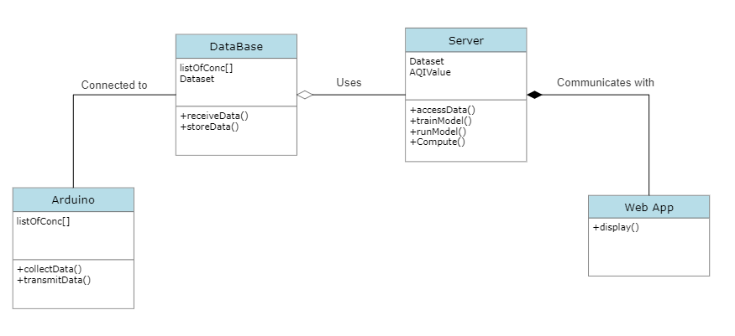

Use Case Diagram
